Project 2 Milestone 2
Business Problem
We will be exploring the relationship between elections in the stock market. We will examine the S&P 500’s future performance relative to various election cycles to determine if there is any correlation between the voter sentiment and the stock market.

Background/History
The S&P is considered the benchmark of American investment. Its performance reflects several things, such as public sentiment, employment, inflation, crisis, and wealth creation. No one knows the future price of the S&P, but quants, economists, and hedge funds explore correlations to future performance to better understand influences.

Elections take place every 2 years in this country and power shifts between two major parties: Democrat and Republicans. While some turbulence occurs (impeachments, resignations, assassinations, refusal to accept nomination, dropping out of race), elections represent the transfer of power between parties, and the entire nation is impacted by the results.

Data Explanation (Data Prep/Data Dictionary/etc.)

To find early performance of the S&P, we can download the symbol GSPC from yfinance, a popular python library for downloading stock data. We then compare January to January to find yearly performance. U.S. elections are manually extracted from 270towin’s election maps. Utilizing the year as the primary key, we can then layer the year over year performance with the elections of presidents over time.

Methods & Analysis

We first group years according to their election mapping. Of the years since 1950, 38 were nonelection years, 19 were midterms, and 19 were presidential. Boxplots excel in showing the distribution of stock market performance. We can clearly see the difference between the non-election year means vs midterm and presidential.

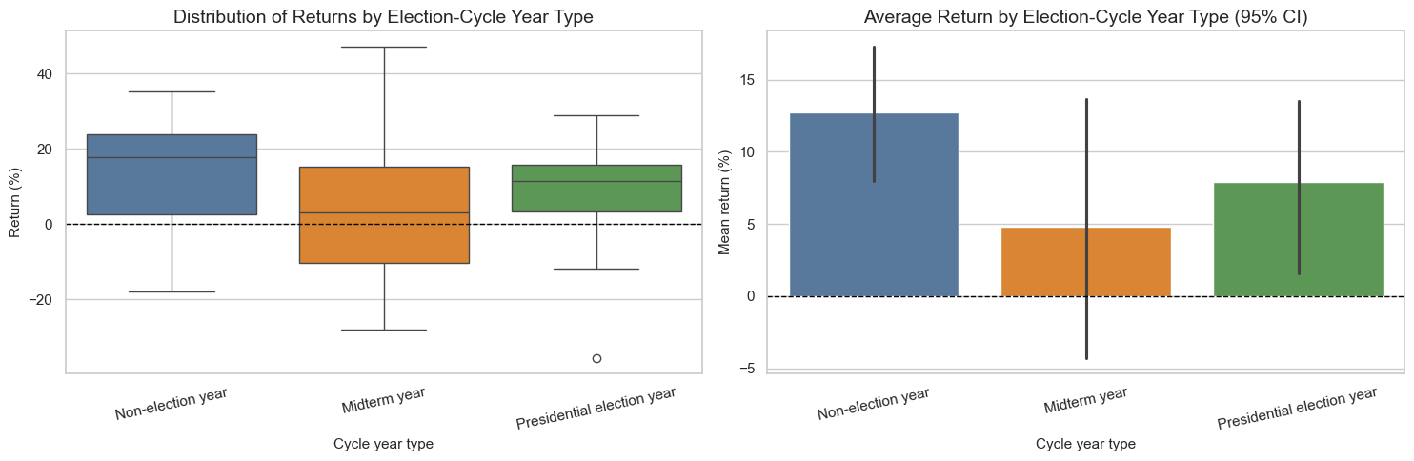

To examine S&P performance over time, we can utilize a line chart over time with returns plotted with Democrat and Republicans. This chart is a big noisier, but that’s because there were no consistent edges for market return based on political party. This is some correlation between massive drops in the market and the “throw the bums out” theory. It’s possible that the 2000 (Democrat), 2008 (Republican), and 2022 (Democrat) returns created market anxiety, which triggered a backlash against the incumbent’s party.

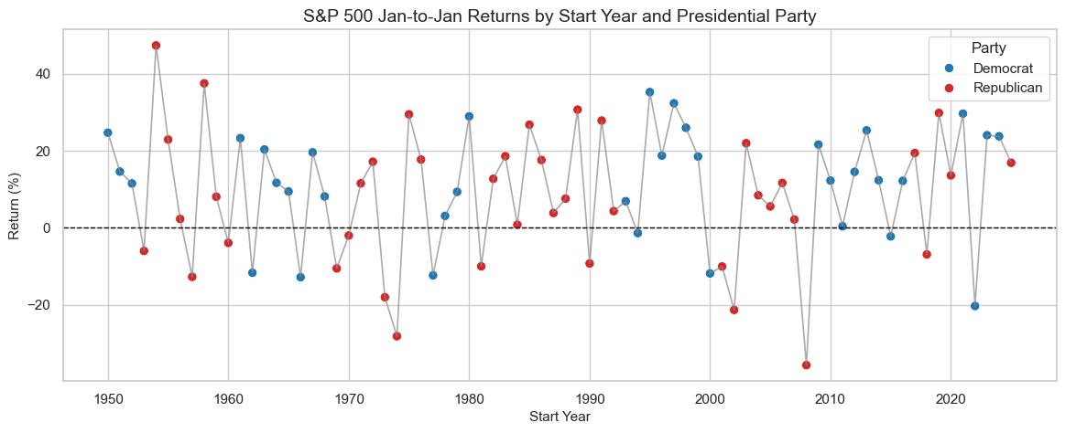

We can also examine the return distribution by party, which on average favors democrats (+12%) over republicans (8%). However, we conducted a t-test, and with a value of 0.19, we reject the null hypothesis that political parties influence future stock market returns. It’s important to note that the Great Depression was omitted due to data starting in the 1950s, but interestingly, that would coincide with more favorable returns from Democrats and negative returns for Republicans.
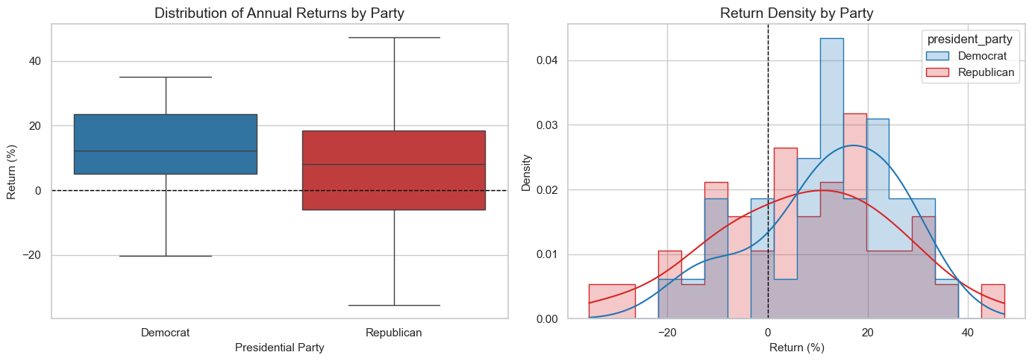

Conclusion

There are several conclusions we can draw from our findings. First, there is large variance for elections cycles. For example, midterms range from -10 to almost +18. Non-election years on average have a return of +12%, election years average +7.8% and midterms average +4.8%.

Because the current year (2026) is a midterm year, we should expect lower returns for 2026. For reference, 2023 (election had +24% return, 2024 (presidential year) had a 25% return and 2025 (non-election) had a +17.9% return.

Because the data was very cut-and-dry, we do not need to assume about the data as they are recorded history.
There are more political patterns to examine (scandals, crisis, etc.) that could likely weigh on the market. It would be challenging to quantify many of those data points. Future uses would include hedging against a possible downturn for historical events. It isn’t recommended to take financial advice from this paper. This paper explores relationships between different concepts (stock market and politics) and not meant as investing advice. Although we highlighted democrats on average have higher performance, this is not an indication that republicans are poor with the economy. In some cases, they just happened to be in office when decade-long problems manifested in a stock crash.

Works Cited:

- 270toWin. (n.d.). Historical U.S. presidential elections 1789–2024. Retrieved February 8, 2026, from https://www.270towin.com/historical-presidential-elections
- Capital Group. (2026). How U.S. midterm elections may affect markets: 5 charts. Retrieved February 8, 2026, from https://www.capitalgroup.com/advisor/insights/articles/midterm-elections-markets-5-charts.html
- Schmid, D. (n.d.). The 4-year election cycle theory and the stock market. PFBT. Retrieved February 8, 2026, from https://www.pfbt.com/the-4-year-election-cycle-theory-and-the-stock-market
- WT Wealth Management. (2024, August). Presidential election cycle theory. Retrieved February 8, 2026, from https://www.wtwealthmanagement.com/whitepapers/2024-08/

10 Questions I anticipate:

• Why did you choose January-to-January returns instead of calendar-year returns or election-day-to-election-day returns?
• How did you assign the presidential party for years with transitions (for example, inauguration years)?
• Which statistical tests did you use to compare party-based returns, and why those tests?
• How reliable is your election file (us_presidential_elections_1952_2024.csv) since it was manually curated in the notebook?
• How did you define “underperformance” for the incumbent-loss analysis, and what happens if you change that definition?
• With only a limited number of presidential elections, do you have enough sample size to make strong conclusions for Question 2?
• Did you test robustness by excluding outlier years like 2008 or 2020 to see if conclusions change?
• Did you control for other macro factors (inflation, Fed rates, recessions, valuations), or is this strictly a politics + returns study?
• For the 2026–2027 forecast, how did you validate model performance out-of-sample, and what does the prediction interval imply?
• How should we interpret your findings: association vs causation, and what are the ethical limits of presenting market predictions?

